

UNIVERSITY PORTAL

(DBMS PROJECT)

**Members:**

Muhammad Arsalan Warsi

(SP19-BSSE-0030 | [sp19bsse0030@maju.edu.pk](mailto:sp19bsse0030@maju.edu.pk))

Aliyan Ahmed

(SP19-BSSE-0028 | [sp19bsse0028@maju.edu.pk](mailto:sp19bsse0028@maju.edu.pk))

**Course:**

Database Management Systems Lab (BM)

TOPIC

UNIVERSITY PORTAL

ANALYSIS OF BUSINESS PROBLEM

There are a number of peoples in a university having different roles. Admin, teachers and students are most important part of the university and it is not easy to manage and maintain all the records accurately. So, the university portal is the best way to maintain the record which allow the admin to view, update, add or delete the data and communicate with students and teachers. The university portal not only allows to do business easily but also saves time, manual paperwork, and manual work force which can help to reduce the cost and save the data accurately.

IDENTIFICATION OF ENTITIES

The following are the entities:

* Admin.
* Faculty.
* Departments.
* Students.
* Courses.
* Enrolled.
* Announcements.
* Notices.

RELATIONSHIP B/W ENTITIES

The following are the relationship between the entities:

* Students has many to many relationship with Course.
* Teacher has one to many relationship with Course.
* Department has one to many relationship with Teacher.

IDENTIFICATION OF USERS

Users are:

* Admin.
* Teacher.
* Student.

USERS ROLES

Admin:

* Admin can add and delete students or faculty members.
* Admin can change or update details of students and faculty members.
* Admin can communicate with students and teachers through notices.

Faculty:

* Teacher can view student details.
* Teacher can communicate with students through announcements.

Student:

* Student can view their details and announcement from teachers and notices from admin.
* Student can check their enrolled course and check attendance.

ENTITY RELATIONSHIP MODELING

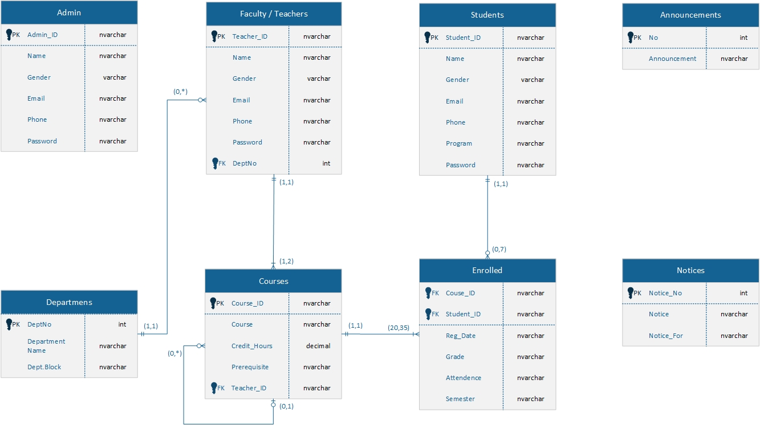

NORMALIZATION

1NF (1st Normal From):

All the entities are in atomic column. All the tables in ERD have uniquely identifying keys (Primary Key).

Reason:

When we save the record in Database the new record will save in next row and each table have PK, so new similar record will save in table.

2NF (2nd Normal From):

In ERD the partially dependencies of tables have been solved. The attributes are functionally dependent on single attribute Primary key, except the enrolled tables because in us created to resolve many to many relationship.

Reason:

If we want to update, add or delete the record in table we only preform DML operation on single table and its impact on different tables.

3NF (3rd Normal From):

The Transitive dependency is resolve by breaking the tables due to non-primary key depend on non-primary key. Like Department table is created separately from teacher’s table.

Reason:

When we add new department or change the details of department it applies on each and every record in teacher’s table, so we did not need to update the details of every single record in teacher’s tables.